Dr. Marlin Samuels, M.D., M.B., ChB

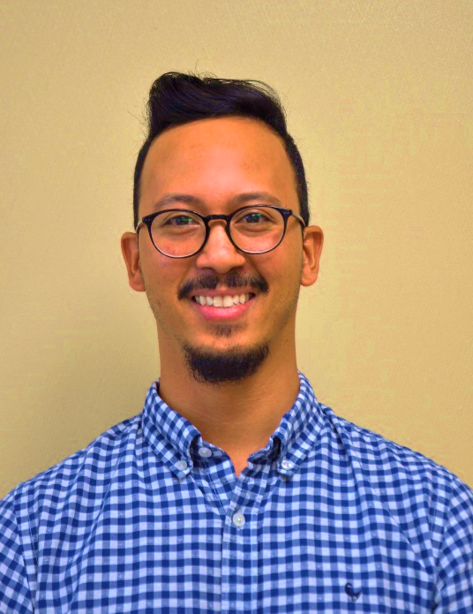
Dr. Marlin Samuels will be the newest member to the Cascade Medical team. Originally from Paarl in the Western Cape of South Africa, he completed his medical degree at the University of Stellenbosch. Dr. Samuels has experience in rural family medicine and emergency medicine with special interest in internal medicine and infectious disease. Dr. Samuels is an adventurer having worked onboard cruise ships prior to relocating to Canada. He was attracted to Princeton by the surrounding nature and abundance of outdoor activities in the area as well as Princeton’s reputation as an exceptionally kind, caring and welcoming community for new doctors. Dr. Samuels has recently completed the Spring intake of the Practice Ready Assessment Program of BC and will be providing a 3 year return of service in Princeton beginning in late August 2018.

Dr. Samuels also maintains the role of Long-Term Care Initiative Team Lead.

